AKSHYA SHARMA

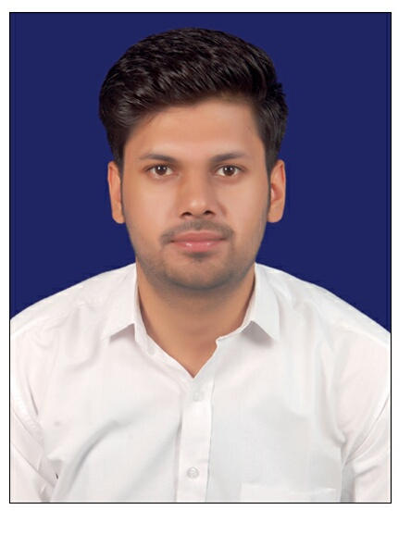
Mob: 9413341200
E-mail: akshyasharma.94@Gmail.com


Career Objective

To pursue a job that provides me a challenging career where I can contribute to the development of organization to the best of my skills

Educational Qualification

Academic and Professional | - M.B.A. from Vivekananda Global University Jaipur.(HR/Marketing) in year 2017 (above 65%)  - B.A from University of Rajasthan, Jaipur  S. S Jain, Subodh PG College, Jaipur in year 2015 (54%)  - Senior Secondary from Board of Secondary Education Rajasthan, Ajmer  Arts in year 2012 (68%)  - Secondary from Board of Secondary Education Rajasthan, Ajmer in year 2010 (58%)

Additional Skills

Technical | - Diploma in RS-CIT  - Working knowledge of Utility and Application Software  - Windows XP and Windows 2007 etc.

Work Experience

Experience | - Presently working with Teleperformance as Customer Care Executive 2016 – present.  - Previously worked with Genpact as Process Acossicate 2015-16  - Worked with Shankar Silvex Pvt. Ltd. as an executive from Sept.2014-2015

Personal Details

Father’s Name | Sh. Triloki Nath Sharma
D.O.B. | 08 May 1994
Sex | Male
Nationality | Indian
Marital Status | Single
Language | Hindi, English
Permanent Address | S/O- Sh. Triloki Nath Sharma  B- 38 Vivek Vihar,  Gandhi Path (West),  200 Feet Byepass Near Vaishali Nagar  Jaipur-302021

Declaration

I hereby declare that the information furnished above is true and complete to the best of my knowledge and belief.

Date:

Place: Jaipur Signature

